Forward Proxy
# Source: Chatgpt (GPT-5-Mini) at [1/16/2026]
A Forward Proxy is a server that sits between a client (like your browser) and the internet, acting as an intermediary for requests from the client.

🧭 Definition:
# Source: Chatgpt (GPT-5-Mini) at [1/16/2026]
A Forward Proxy is used by clients to access resources on other servers, often to:
- Hide the client’s identity (IP address)
- Bypass geographic or content restrictions
- Enforce security or content policies
- Cache content to improve performance

🧱 How It Works:
# Source: Chatgpt (GPT-5-Mini) at [1/16/2026]
- You request a website (e.g., example.com).
- The Forward Proxy receives your request.
- The proxy sends the request to example.com on your behalf.
- The website sends the response to the proxy, not directly to you.
- The proxy then forwards the response to you.

📌 Diagram:
# Source: Chatgpt (GPT-5-Mini) at [1/16/2026]

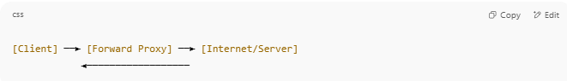

[Client] ──► [Forward Proxy] ──► [Internet/Server]
◄──────────────────

🛡️ Use Cases:
# Source: Chatgpt (GPT-5-Mini) at [1/16/2026]
- Anonymity: Hides your real IP address.
- Access Control: Block or allow access to specific sites (used in schools/offices).
- Caching: Stores popular pages to speed up loading.
- Filtering: Blocks malicious or restricted content.

🔁 Forward Proxy vs Reverse Proxy:
# Source: Chatgpt (GPT-5-Mini) at [1/16/2026]
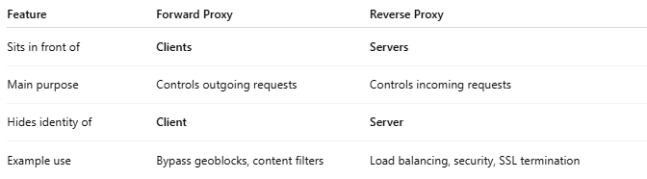

Feature | Forward Proxy | Reverse Proxy
Sits in front of | Clients | Servers
Main purpose | Controls outgoing requests | Controls incoming requests
Hides identity of | Client | Server
Example use | Bypass geoblocks, content filters | Load balancing, security, SSL termination

